Added React Developer Tools chrome extension.

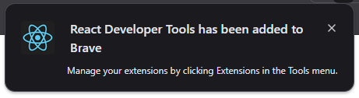

Allowed access to file URLs

